Instructions to Authors Preparing Their
Camera Ready Papers for Int.WOJDE Journal

First AUTHOR , ORCID
author1@mailserver.com
Institution, Country
Second AUTHOR , ORCID
author2@mailserver.com
Institution, Country
Third AUTHOR , ORCID
author3@mailserver.com
Institution, Country

ABSTRACT

An informative, comprehensive abstract of 200 to 250 words must also be submitted and typed on a separate page. This abstract should succinctly summarize the major points of the paper, and the author's summary and/or conclusions. Start the abstract with the sequence "ABSTRACT" (without the quotes and in capital letter) in 10 point bold-face without a line break after "Abstract:" in blue color. Leave 1 blank line after the abstract.

Keywords: NOT exceed 7 words. Keywords must appear after the abstract on the same separate page in red color.

INTRODUCTION

All manuscripts are acknowledged upon receipt. Review is carried out as promptly as possible. The manuscript will be reviewed by at least three members of the Editorial Review Board, which takes approximately from one week to the three months by tolerance of Editor-I-Chief of Int.WOJDE. However, the manuscript submitted by the Editor/s of Int.WOJDE will NOT be reviewed ethically. When a decision for publication or rejection is made, the senior author or author designated to receive correspondence is notified. At the time of notification, the author may be asked to make certain revisions in the manuscript, or the Editor may submit suggested revisions to the author for approval.

Articles must be sent as an attachment to your e-mail address intwojde@gmail.com by corresponding authors. Microsoft WORD is the preferred word processor format. Written manuscripts should be in English.

The manuscript must conform to the style of the Publication Manual of the American Psychological Association (APA), 7th Edition.

Manuscripts should be single-spaced. Font face must be Tahoma in 10 punto, and in bold style. Paper Size must be A4.

COPYRIGHT

This journal is copyrighted by Int.WOJDE. Material published and so copyrighted may not be published elsewhere without the written permission of Int.WOJDE. No manuscript will be considered which has already been published or is being considered by another journal if not necessary.

TITLE

The title should start with a capital letter, unnumbered and centered between the margins. Use a Tahoma, 14 point, bold font for the title. The body of the paper must begin immediately after the title. Leave 2 blank lines after title.

RUNNING TEXT

In general, manuscripts must be between 10 and 15 single-spaced pages including the references, figures, and tables. Research Briefs and Notes for Editor, Reviews may be shorter, normally between 03 –15 pages. Use italic print to emphasize words (Bold type and underlining must be avoided).

The text must always be justified to occupy the full line width, so that the right margin is NOT ragged. Leave 1 blank lines at the end of the text.

Biodata and contact Addresses must be indicated via portrait photo and full contact addresses. Please provides scholarly information about author/s of 100 to 150 words must also be submitted. Leave 2 blank lines after biodata with a capital letter and in blue color.

TABLES, FIGURES, EQUATIONS

Illustrations and tables should be progressively numbered, following the order cited in the text. Tables must be accompanied by a caption placed at the top. Figures (abbreviated Figure X in the caption and Fig. X in the text) must be accompanied by a caption placed underneath ("Figure Caption" style).

Table I. The Recommended Fonts
Item | Style (from "Style and Formatting")

When inserting figures, they should be as clear as possible. Figures must be centered. Do not use font sizes smaller than 8 Tahoma, as they will be difficult to be read.
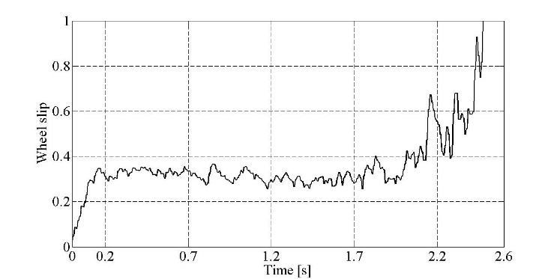
Figure 1. Wheel slip response with the proposed control algorithm
Color pictures are also acceptable, but you have to be sure they will be also visible on grayscale printing. In the online version of your paper they will be in color version.

MATH

Use either the Microsoft Equation Editor or the MathType add-on (http://www.mathtype.com) for equations in your paper (Insert | Object | Create New | Microsoft Equation or MathType Equation). “Float over text” should not be selected.

Each formula should occupy one line. Consecutive numbers should be marked in brackets. All equations should be numbered (the numbers should be aligned at the right), and cited (1) in the text.

FINANCIAL SUPPORT

Work reported or a grant under which a study was made must be noted just prior to the Acknowledgments. Leave 2 blank lines after financial support.

ACKNOWLEDGMENTS

This is an optional section. Acknowledgments or appreciation to individuals for assistance with the manuscript or with the material reported should be included as a note to appear at the end of the article prior to the References in red color. Leave 2 blank lines after acknowledgments.

REFERENCES

Reference must conform to the style of the Publication Manual of the APA7th Edition. Start the reference(s) with the sequence "References:" (without the quotes) in 10 point bold-face Tahoma and leave 1 blank line after "Reference" with capital in blue color.

SOME COMMON MISTAKES

The word “data” is plural, not singular. The subscript for the permeability of vacuum µ0 is zero, not a lowercase letter “o.” Use the word “micrometer” instead of “micron.” A graph within a graph is an “inset,” not an “insert.” The word “alternatively” is preferred to the word “alternately” (unless you really mean something that alternates). Use the word “whereas” instead of “while” (unless you are referring to simultaneous events). Do not use the word “essentially” to mean “approximately” or “effectively.” Do not use the word “issue” as a euphemism for “problem.” Be aware of the different meanings of the homophones “affect” (usually a verb) and “effect” (usually a noun), “complement” and “compliment,” “discreet” and “discrete,” “principal” (e.g., “principal investigator”) and “principle” (e.g., “principle of measurement”). Do not confuse “imply” and “infer”.

Prefixes such as “non,” “sub,” “micro,” “multi,” and “ultra” are not independent words; they should be joined to the words they modify, usually without a hyphen. There is no period after the “et” in the Latin abbreviation “et al.” (it is also italicized). The abbreviation “i.e.,” means “that is,” and the abbreviation “e.g.,” means “for example” (these abbreviations are not italicized).

BIODATA and CONTACT ADDRESSES of the AUTHOR/S

What You Should Do?
- Start with your full name followed by your current position, your general interests, and your current project, keeping them all very brief.
- If you are within a year of receiving a prestigious award, mention that as well.
- Finally, finish with a sentence that’s personal: add a hobby, a pet’s name, the city you live in—whatever you are comfortable with that is personal but not too private.
What You Should Avoid?
- Avoid speaking in the first person, i.e., don’t use “I.”
- Don’t divulge details beyond your current position.
- In a longer bio of multiple paragraphs, you may add more awards and information about your master’s and bachelor’s degrees, but not in a short bio. Moreover, don’t add anything that happened before grad school—including your place of birth.

Author Name (Academic Title)
Contact Addresses
Phone Office:
E-mail:
URL:

IMPORTANT
PLEASE CAREFULLY READ AND ADHERE TO THESE GUIDELINES.
MANUSCRIPTS NOT SUBMITTED ACCORDING TO THE GUIDELINES WILL BE REJECTED AND RETURNED TO THE AUTHOR/S.

http://www.wojde.org/?pnum=7&pt=Call+for+Papers

